COMPUTERIZED ADAPTIVE TESTING USING THE NEAREST-NEIGHBORS CRITERION

Philip E. Cheng*
Michelle Liou
2002

Philip E. Cheng and Michelle Liou are Research Fellows, Institute of Statistical Science, Academia Sinica, ROC. The authors are indebted to the editor and reviewers for helpful comments. This research was supported by grant NSC90-2118-M-001-024-037 from the National Science Council, ROC. Correspondence: Michelle Liou, Institute of Statistical Science, Academia Sinica, Taipei 115, Taiwan, ROC. E-mail: mliou@stat.sinica.edu.tw

Abstract
Item selection procedures designed for computerized adaptive testing need to accurately estimate every taker’s trait level () and, at the same time, effectively use all items in a bank. Empirical studies showed that classical item selection procedures based on maximizing Fisher or other related information yielded highly varied item exposure rates; with these procedures, some items were frequently used whereas others rarely selected. In the literature, methods have been proposed for controlling exposure rates; they tend to affect the accuracy in estimates, however. A modified version of the maximum Fisher information (MFI) criterion, coined the nearest-neighbors (NN) criterion, is proposed in this study. The NN procedure improves to a moderate extent the undesirable item exposure rates associated with the MFI criterion, and keeps sufficient precision in estimates. The NN criterion will be compared with a few other existing methods in an empirical study using the mean squared errors in estimates and plots of item exposure rates associated with different distributions.
Key words: Computerized adaptive testing, density estimation, Fisher information, item response theory, selection criteria, trait estimation, item exposure rates.

Introduction

A primary concern of CAT lies in estimating every taker’s trait level () accurately using items in a well designed bank with balanced contents and properly calibrated item parameters. For security or disclosure considerations, it is undesirable to administer the most discriminating items frequently through test sessions. Ideally, item selection procedures should balance two competing demands: to preserve accuracy in estimates on one hand, and to effectively use all items in the bank on the other. Accuracy in estimates is normally measured by the mean squared errors across true values. Items exposure rates may be plotted in accordance with the order of their magnitudes, and effective item usage is shown by how nearly the plots exhibit a flat and uniform shape. For classical paper-and-pencil tests, uniform exposure rates are simply built in test designs. Item overexposure occurs when items have to be tailored to takers with balanced contents and suitable item difficulties. For example, if a group of takers are homogeneous in , the most discriminating items with difficulties close to these values tend to have high exposure rates.
With parametric item response models, both the maximum likelihood (Lord and Novick, 1968; Lord, 1980; Weiss, 1982) and Bayesian methods (Owen, 1975; Bock & Mislevy, 1982) provide reasonable precision in estimates, but at the same time, give extremely skewed exposure rate plots. Empirical studies showed that item selection procedures maximizing Fisher information (MFI) would yield overexposure of items with high discrimination information and underexposure of those with lower discrimination (McBride & Martin, 1983; Weiss & McBride, 1984). Conventionally, the MFI selects an item whose Fisher information (FI) evaluated at the current estimate is a maximum. A general weighted information criterion discussed by Luecht (1995) and Veerkamp and Berger (1997) selects items by evaluating an integral of weighted FI over a interval defined by the current estimate. Chang and Ying (1996) suggested replacing the item FI by an integrated Kullback-Leibler divergence (KL) over intervals. For a Bayesian analog, van der Linden (1998) proposed the maximum expected (posterior weighted) information (MEI) criterion as an alternative to the minimum expected posterior variance criterion due to Owen (1975). He also showed that the Bayesian procedures enjoyed asymptotic equivalence to the MFI in selecting items for long tests, and had better mean squared errors in small samples. The resulting item exposure rates from the abovementioned criteria have yet to be examined, however.
Methods have been proposed to adjust item exposure rates using additional control parameters (Mills & Stocking, 1996; Stocking & Lewis, 1995; Sympson & Hetter, 1985). These methods effectively reduced items overexposure exceeding the average level, but enlarged errors in estimates. The latter drawback seemed to be another CAT issue that was not much discussed in the literature. Chang and Ying (1999) suggested the a-stratified method for controlling exposure rates; the method also yielded less accurate estimates as compared with the classical MFI criterion. In our empirical studies, the optimal item difficulty (OID) method suggested by Lord (1980) always gave more uniform exposure rates, but slightly poorer estimation precision. A new item selection method, coined the nearest-neighbors (NN) criterion, is proposed in this study based on the theory of density estimation (e.g., Mack & Rosenblatt, 1979). The NN procedure is designed to balance estimation precision and effective item usage by combining the MFI criterion with the OID method.
Previous studies using integrated information (e.g., FI or KL) over a interval computed the criterion values for all the remaining items in the item pool and administered the one with the maximum criterion value. The proposed NN method selects the next item having the maximum FI (eq. (17) below) among those whose optimal item difficulty parameters are the nearest neighbors of the current estimate. In other words, the candidate items for the next item administration must be nearest neighbors rather than all the remaining items in the pool. Similar to many information-criterion based methods, item administration with the NN criterion is automatic without using any control parameters. Bias correction in estimates has been suggested for CAT, especially at earlier stages of item administration (Cheng & Liou, 2000). In this study, estimates using the weighted maximum likelihood method (Warm, 1989) are considered along with a Bayesian analog. The proposed NN criterion and other item selection methods will be evaluated on both accuracy in estimating and ranges of item exposure rates in an empirical study using different distributions.

Estimation Accuracy and Exposure Rates

The three-parameter item response model defines the probability of a correct answer to an item, given a taker’s trait as
(1)

Here X is binary 0-1 valued and F is a known distribution function which is commonly selected to be the standard normal or the logistic distribution function. The triplet specifies the item discrimination , difficulty ( real) and guessing parameters, respectively (Birnbaum, 1968; Lord & Novick, 1968). For notational simplicity, set $t=a(θ−b)$. This study considers the 3-parameter logistic model (3PLM), that is,
(2)

where D is a scaling constant (e.g., D = 1.7; Lord, 1980). The value is commonly estimated by the maximum likelihood method or a Bayesian procedure. In CAT applications, is usually estimated using a small number of item responses and, either the maximum likelihood estimate (MLE) or the Bayesian modal estimate is biased in small samples (e.g., Anderson & Richardson, 1979; Lord, 1983). The weighted likelihood equation given the item parameters and binary response , $i=1,⋅⋅,L$, is
(3)

where defines the usual log-likelihood and the score equation whose solutions are the (possibly unique) MLE. Individual terms in (3) are
$l=\sum_{i=1}^{L}{\frac{{\text{Da}}_{i}}{1+c_{i}\text{exp}(−{\text{Dt}}_{i})}}\left[X_{i}−c_{i}−\frac{1−c_{i}}{1+\text{exp}(−{\text{Dt}}_{i})}\right]$, (4)

$λ(θ)=\frac{1}{I^{2}(θ)}\sum_{i=1}^{L}{{\text{Da}}_{i}I_{i}(θ)\left[\frac{1}{1+\text{exp}(−{\text{Dt}}_{i})}−\frac{1}{2}\right]}$ and (5)

$I(θ)≡\sum_{i=1}^{L}{I_{i}(θ)}=\sum_{i=1}^{L}{\frac{({\text{Da}}_{i})^{2}(1−c_{i})\text{exp}(−{\text{Dt}}_{i})}{[1+\text{exp}(−{\text{Dt}}_{i})]^{2}[1+c_{i}\text{exp}(−{\text{Dt}}_{i})]}}$. (6)

Equation (5) is the first-order bias of the MLE, and (6) defines the total FI function as a sum of item information given by the items. According to Warm (1989), is eliminated by solving (3) for . The solution, called the weighted likelihood estimate (WLE denoted ), yields
(7)

where$\left|o(1/L)L\right|→0$ as . Thus has the same asymptotic variance as does the usual MLE but with smaller bias.
From the discussion of Warm, it can be shown that a Bayesian analog of (3) with a normal prior for is the equation
$l_{B}−λ_{B}(θ)I_{B}(θ)=0,\text{ where}$ (8)

(9)

$λ_{B}(θ)=λ(θ)−\frac{θ−μ}{I(θ)σ^{2}}\text{ and}$ (10)

(11)
As , equation (8) reduces to (3); the Bayes weighted likelihood estimate (BWLE) reduces to .
In a CAT session, items are selected from a bank with items and administered to a finite population having takers. A fixed test length is often decided such that each taker will be given at most test items. Accuracy in estimates is usually assessed by the mean squared error (MSE); the sample version is
(12)

that can only be measured with known true values. Therefore, simulation results on relative sizes of MSE between item selection criteria are conditioned upon the given item parameters and distributions.
Effective use of any item bank depends on the corresponding population. A standard measure has been the exposure rate which is the relative frequency of an item used throughout test sessions (e.g., Sympson & Hetter, 1985; Chang & Ying, 1999). The th item exposure rate of a test session was defined to be

(13)

If is the average test length (or the fixed test length), the average exposure rate is

(14)

which is a constant; the discrepancy between the constant and observed item exposure rates was commonly measured by the Pearson chi-squared statistic:

(15)

The smaller the value was, the more effectively an item bank was in use. In CAT applications, it has been observed that effective item usage and accurate estimates may not be acquired at the same time. Constant exposure rates are only obtainable with a completely random selection scheme, which can yield large MSE on intuitive grounds. Given any item bank and distribution, the relative performance between (12) and (15) depends mainly on the design of item selection criteria.

Performance of Item Selection Procedures

Many classical well-known CAT algorithms were based on the MFI criterion. For , the th item is chosen from the bank if it gives the maximal FI value at the current estimate , that is, in (6) is maximized with the chosen item. It follows that items with larger and smaller are more likely to be selected by the MFI criterion (Weiss, 1982; Hambleton & Swaminathan, 1985). Empirical studies showed that algorithms using MFI always resulted in smaller MSE compared to those using other selection criteria (e.g., Cheng & Liou, 2000). However, if a major portion of values were located around any distribution modes, CAT could repeatedly select items with larger FI for estimating these values and, as a consequence, gave larger values in (15).
There have been procedures available for restricting individual exposure rates at a ceiling level. The Sympson and Hetter method (SH; 1985), notably among others, was designed to limit the chance of item administration (exposure) by some pre-assigned control parameters; that is, . For each item selected, it empirically updates the chance of selection and implements via randomization. By adding control parameters to item selection procedures, the SH method could effectively limit the maximal exposure rates and also the values in (15), but failed to increase the rates for those underexposed items (e.g., Chang & Twu, 1998; Chang & Ying, 1999).
A Bayesian variant of the MFI was the MEI criterion proposed by van der Linden (1998). After observing the method computes the expected information of all the remaining items in the pool and selects the th item that maximizes the criterion value:
(16)
Here J( is the observed information (i.e., minus the second derivative of the likelihood function) evaluated at $θ$, and at the two trait estimates ${\hat{θ}}^{(k+1)}$ given $X_{k+1}=0\text{ or 1}$. In his empirical study, van der Linden (1998) used a normal prior distribution in estimating $θ$, assuming that there were some background variables for predicting $θ$. As such background information was not assumed in this study, it was standard to use a uniform prior having a wide range, a case in which the BWLE given in (8) reduced to Warm’s WLE. For computational simplicity, the predictive weights in (16) were replaced by the conditional probability given the current ${\hat{θ}}^{(k)}$, that is, replacing $P(X_{k+1}=0|X_{1},⋅⋅,X_{k})$ with $P(X_{k+1}=0|{\hat{θ}}^{(k)})$. This simplification was validated by a first-order approximation to (16) (cf. van der Linden, 1998, formula (13)) when the posterior distribution of $θ$ given $X_{1},⋅⋅,X_{k}$ supported a small $θ$ interval centered at ${\hat{θ}}^{(k)}$ and the uniform prior was in use. Moreover, it essentially kept the same performance as the MEI, and saved CPU time without computing the posterior integrals.
Lord (1980, p.159) stated: ”if it is somehow uneconomical to make heavy use of the most discriminating items in a pool, one could require that item selection should be based only on item difficulty and not on information or discriminating power.” This suggested an idea toward reducing the drawback of exposure rates with the MFI, a point that turns out to be intuitively meaningful for developing new selection criteria. From (6), the maximum FI value given by a triplet is
(17)
which is obtained at $θ=b^{'}$, called the OID criterion by Lord (1980), where $b^{'}=b+\frac{1}{\text{Da}}\text{log}\left(\frac{1+\sqrt{1+8c}}{2}\right),$ and (18)
$\text{exp}[\text{Da}(b−b^{'})]=\frac{2}{1+\sqrt{1+8c}}\text{.}$ (19)
It is worth noting that ; if , then $b^{'}=b$ and . When in (2) is the standard normal distribution, results similar to (17) and (18) also hold but with more complicated forms. The OID procedure selects the next item whose $b^{'}$ value is nearest to the current . The performance of the OID in trait estimation and the associated exposure rates had not been thoroughly investigated in the literature.
It is worth noting that consistency and asymptotic normality in estimating can be verified for the OID method if the item bank contains enough items such that there is always an available item whose $b^{'}$ value is close enough to the current estimate. Thereby, like the MFI, standard large sample theory is also valid for the OID though less efficient. Lord (1980) proposed the OID method simply for alleviating item overexposure with the MFI but not for better precision in estimating . In simulation studies, the plots of exposure rates for the OID method were closer to a uniform shape but had larger MSE compared to other selection procedures.
Chang and Ying (1999) suggested that the discrimination parameter should be considered separately from other information indices during item selection. Primarily, items with larger values were reserved for later stages when more information about was obtained. The proposed -stratified method began by sorting items in ascending order of the values then dividing them into strata of alike values. Items with smallest will be selected first, followed by those with larger . To proceed, the method selected from each stratum the next item whose value was nearest to the current estimate. Theoretical analysis of a proper -stratification and related asymptotic properties were not given. By an empirical study, they showed that the -stratified method without the SH control yielded reasonable MSE and better exposure rates, compared with the MFI (Weiss, 1982) and Bayesian methods (Owen, 1975; Bock and Mislevy, 1982) both using the SH control.
Except for the SH scheme, all the methods illustrated above did not require item exposure control parameters via randomization. McBride and Martin (1983) proposed a semi-random item selection method (hereafter, M&M) in order that examinees with similar receive different items. In a typical approach, the M&M selected the first item randomly from a group of five with largest FI evaluated at the current , the second randomly from a similar group of four, the third from such three, and continued till the fifth then subsequent items chosen by the MFI method. The method controlled overexposure of early items administration, and the resulting exposure rates closely resemble those of the MFI. Variants of this scheme can be made, for example, replacing the 5-4-3-2-1 sequence by a stepwise decreasing one in a wider range, say, from to 1, for the stages of item administration. This modified M&M was used in our empirical study.
A short summary of the above discussion motivates further study. Concerning uniformity of item exposure rates, the OID procedure yielded the best performance, followed by the -stratification and then by the MFI. A reverse order on the MSE performance was observed for the three procedures. The M&M and the MEI methods seemed to perform similarly to the MFI method. The basic facts reconfirmed that criteria designed for increasing precision and for controlling exposure rates may compete with each other in item selection. It was not easy to define a meaningful balance between the two measures. The MSE might become an overriding consideration in CAT designs for certain tests, say, licensing and screening tests. In what follows, an intuitively simple selection criterion is proposed which offers some flexibility in selecting between the two competing goals. It could be motivating to consider first a special situation. Suppose the item parameters in a bank were nearly constant or, homogeneous across the item (or $b^{'}$) parameters whose distribution was the same as that of the population parameters; was there a good and naive selection scheme, given the upper limit items for all examinees?

The Nearest-Neighbors Selection Criterion

In CAT applications, it is reasonable to assume that the distribution of and that of item difficulty parameters do not widely differ in shape and location. If there were no item difficulty values suitable for testing any intervals of values, both accuracy in and item exposure rates would be seriously deteriorated. At early stages of item administration, knowledge about a taker’s is limited, thus may be erroneous and can be far away from its estimate. The WLE fluctuates less widely as more items are administered and its nearest neighbors may enclose true . In order to reduce the MSE, the most informative items having the largest values in (17) must be selected sequentially from neighborhoods of the current . The OID method suggests that the neighborhood can be meaningfully defined as a set of items whose $b^{'}$ values are nearest to the current estimates. When the standard errors of become smaller, the number of nearest neighbors can also be reduced sequentially till the end of item administration. In empirical studies, as the number of nearest neighbors was fixed at 3 to 6 for , the proposed criterion improved exposure rates but gave larger MSE for . Keeping a larger number of neighbors, on the other hand, would increase the value. The NN selection procedure is formulated and outlined as follows.
Assume for simplicity a selection method was designed with fixed test length for all test takers.
Step 1: store in advance the values and $b^{'}$ values in (17) and (18), respectively, for all items in the bank;
Step 2: specify a non-increasing sequence of integers for .
Step 3: initialize the WLE , say, .
For , repeat Steps 4 and 5.
Step 4: find new items whose $b^{'}$ values are nearest to .
Step 5: select among the neighbors the one with the maximum value to be the th item and compute .

A few points about the procedure can be observed. Firstly, item administration in the NN procedure is automatic without referring to exposure control parameters. Next, the WLE of (3) is recommended to replace the usual MLE in estimating . Thirdly, the sequence in Step 2 is not uniquely defined, but they should be non-increasing and unfixed as was discussed. The selection design of Steps 4 and 5 does not evaluate FI at for the remaining items in the pool; it selects the item with the maximum value in (17) among the nearest neighbors of . Our empirical experience suggested that a stepwise decreasing sequence , say, from to usually gave reasonable MSEs and values for and, reducing to 1 near the end of the test can help to reduce the values. Setting for all , the NN degenerates to the OID method. Moreover, fixing to be a constant between and will usually yield larger value without significantly reducing the MSE. The performance of the NN procedure is evaluated below and compared with the selection methods discussed above.

Comparisons between Item Selection Procedures

In the empirical study, two item banks were constructed; one was relatively large in size compared to the other. The small bank consisted of calibrated IRT parameters for items selected from the 1992 NAEP Reading Assessment (Johnson & Carlson, 1994, pp 621-626). The study included 83 items in Reading to Literary Experience and 120 items in Reading to Gain Information. The ranges and mean values of item parameters were: (i) range = (0.452, 2.502), range = (-2.325, 3.061), range = (0.000, 0.373), and (ii) mean = 1.190, mean = -0.024, mean = 0.124. The larger bank consisted of items from the 1990 NAEP Mathematics Main and Cross-Sectional Assessments (Johnson & Allen, 1992, pp 581-587). Tests in the Main Assessment were designed for three age groups (i.e., Ages 9, 13 and 17) and IRT parameters were separately calibrated using different groups. There were some common items shared by the Main and Cross-Sectional Assessments. This study transformed item parameters in the Main Assessment to the scale of the Cross-Sectional Assessment using the equated method (Kolen & Brennan, 1995). There were in total 622 assessment items in multiple-choice formats measuring mathematical performance on Numbers/Operations, Measurement, Geometry, Data Analysis, Algebra/Functions, and Estimation. The ranges and mean values of item parameters were: (i) range = (0.321, 4.260), range = (-3.958, 5.275), range = (0.000, 0.578), and (ii) mean = 1.360, mean = 0.369, mean = 0.149.
The NAEP items measure different content areas. In real applications, item administration must also consider content balance. This study investigated accuracy in and item exposure rates using item banks of different sizes without making further constraints on content balance. If more constraints were made, errors in could be larger and sizes of values could possibly be smaller compared to those reported in this study. The amount of over/under estimation in the criterion values was assumed evenly accounted for by all selection methods. Examinees’ values were randomly generated from target populations: N(-0.023, 1) and N(1, 1) for the small bank; and, N(0.369, 1) and N(-1, 1) for the larger bank. Note that the decimal mean values were chosen to coincide with the average item difficulties of the two banks, but integer mean values were set further away from these averages in order to find any differential effects due to varied locations of the distribution. Given these true item parameters and distributions, item responses were generated from the known in (1). For a given , item selection and estimation were carried out sequentially and stopped at = 20 and 30, respectively for the small and larger item banks. The item with a = 2.06, b= .019 and c = .177 was used as the starting item in the CAT sessions for the smaller bank, and a = 2.262, b = .079 and c = .000 for the larger bank.
There were six selection methods considered in the empirical study, the OID, MFI, M&M, MEI, -stratified, and the proposed NN criteria. The first two classical methods were chosen for showing their extreme performances with short test lengths. The M&M criterion was modified to have a sequence of items in choice, , respectively, during the stages of random selection. The predictive weights in the MEI criterion were modified as previously noted, since the BWLE was replaced by the WLE. For the -stratified method, items were divided into stratas in ascending order of the values, four stratas for the small bank and eight for the larger bank. It was found that slight variation in strata numbers did not notably affect the simulation results. For the NN method, the current report used the sequence of non-increasing numbers , respectively, in defining the nearest neighbors for the stages of item selection. It was also found that slight changes to other non-increasing sequences made little difference in the results. There were random 1,000 takers simulated to evaluate each combination of item banks, populations, and item selection criteria.
Figures 1 through 4 gave the the MSE plots at every stage of item administration for the six selection methods. The plots at early stages might be based on estimates less than 1,000 because could not be estimated for non-Bayesian methods unless a taker had at least one correct and one incorrect answers. The figures also displayed the observed exposure rates sorted in ascending order for all items in each bank. The values measuring exposure rates were also listed in the figure captions (in parentheses) for the six item selection methods. The empirical study was focused on CAT with moderate to short test lengths. Results in all figures showed that the four criteria MFI, M&M, MEI and NN generally yielded comparable MSE, which were smaller than those given by the OID and -stratified criteria. More specifically, the MEI gave the least MSE at early stages of item administration but the worst exposure rates, and the MFI offered the best MSE toward the end of the test. Compared to the last two, the M&M had slightly better exposure rates but comparable MSE to the MFI at early stages. In all figures, the plots of exposure rates of the MFI, M&M and MEI were almost flat for a major portion of the items in each bank, then sharply increased for the remaining items. The OID criterion gave the best control over exposure rates but slightly larger MSEs across item banks and distributions. The MSE for the OID and -stratified methods were always comparable to each other. The proposed NN method achieved more accurate estimates than did the OID and the -stratified, but was slightly inferior to the other three methods toward the end of item administration. The -stratified method gave better exposure rates than did the NN method when the mean of the distribution equaled the average item difficulty, but became worse otherwise. The NN method seemed to be reasonably robust to mild average differences between and item difficulty.

Concluding Remarks

It was enlightening that the OID criterion by Lord (1980) was found to give the most uniform exposure rates but larger MSE. The sharp contrast between the accuracy in trait estimation and items exposure rates motivated our proposal of the NN criterion which is a compromise between the OID and the MFI methods. Although the NN criterion was basically concerned with the accuracy of , it was also designed in the spirit of density estimation to alleviate the poor exposure rates with the MFI. In CAT applications, the NN criterion was comparable to the -stratified method in exposure rates, but it usually achieved better precision in estimating within finite test lengths. In particular, the NN and the MEI criteria yielded the least MSE at early stages of item administration, a fact that merits further study on sequential stopping rules.
To conclude, it was noteworthy that effective use of an item bank may not be easily defined and the statistic was just a simple summary. Plotting curves of ordered exposure rates provided only visible comparisons. It was natural to speculate that the Kullback-Leibler divergence, between the distribution of the item difficulty (or $b^{'}$) parameter and that of those administered, provided a meaningful index; the smaller the KL divergence, the more uniform the exposure rates. This basic observation suggested using density estimation as a natural tool for related assessments, hence the proposed NN criterion. Analogues of this study can be considered for the Bayesian selection criteria as well. In light of accelerated computers, it can be useful to design exposure-control randomization with any selection criteria. These relevant ideas remain for further investigation.

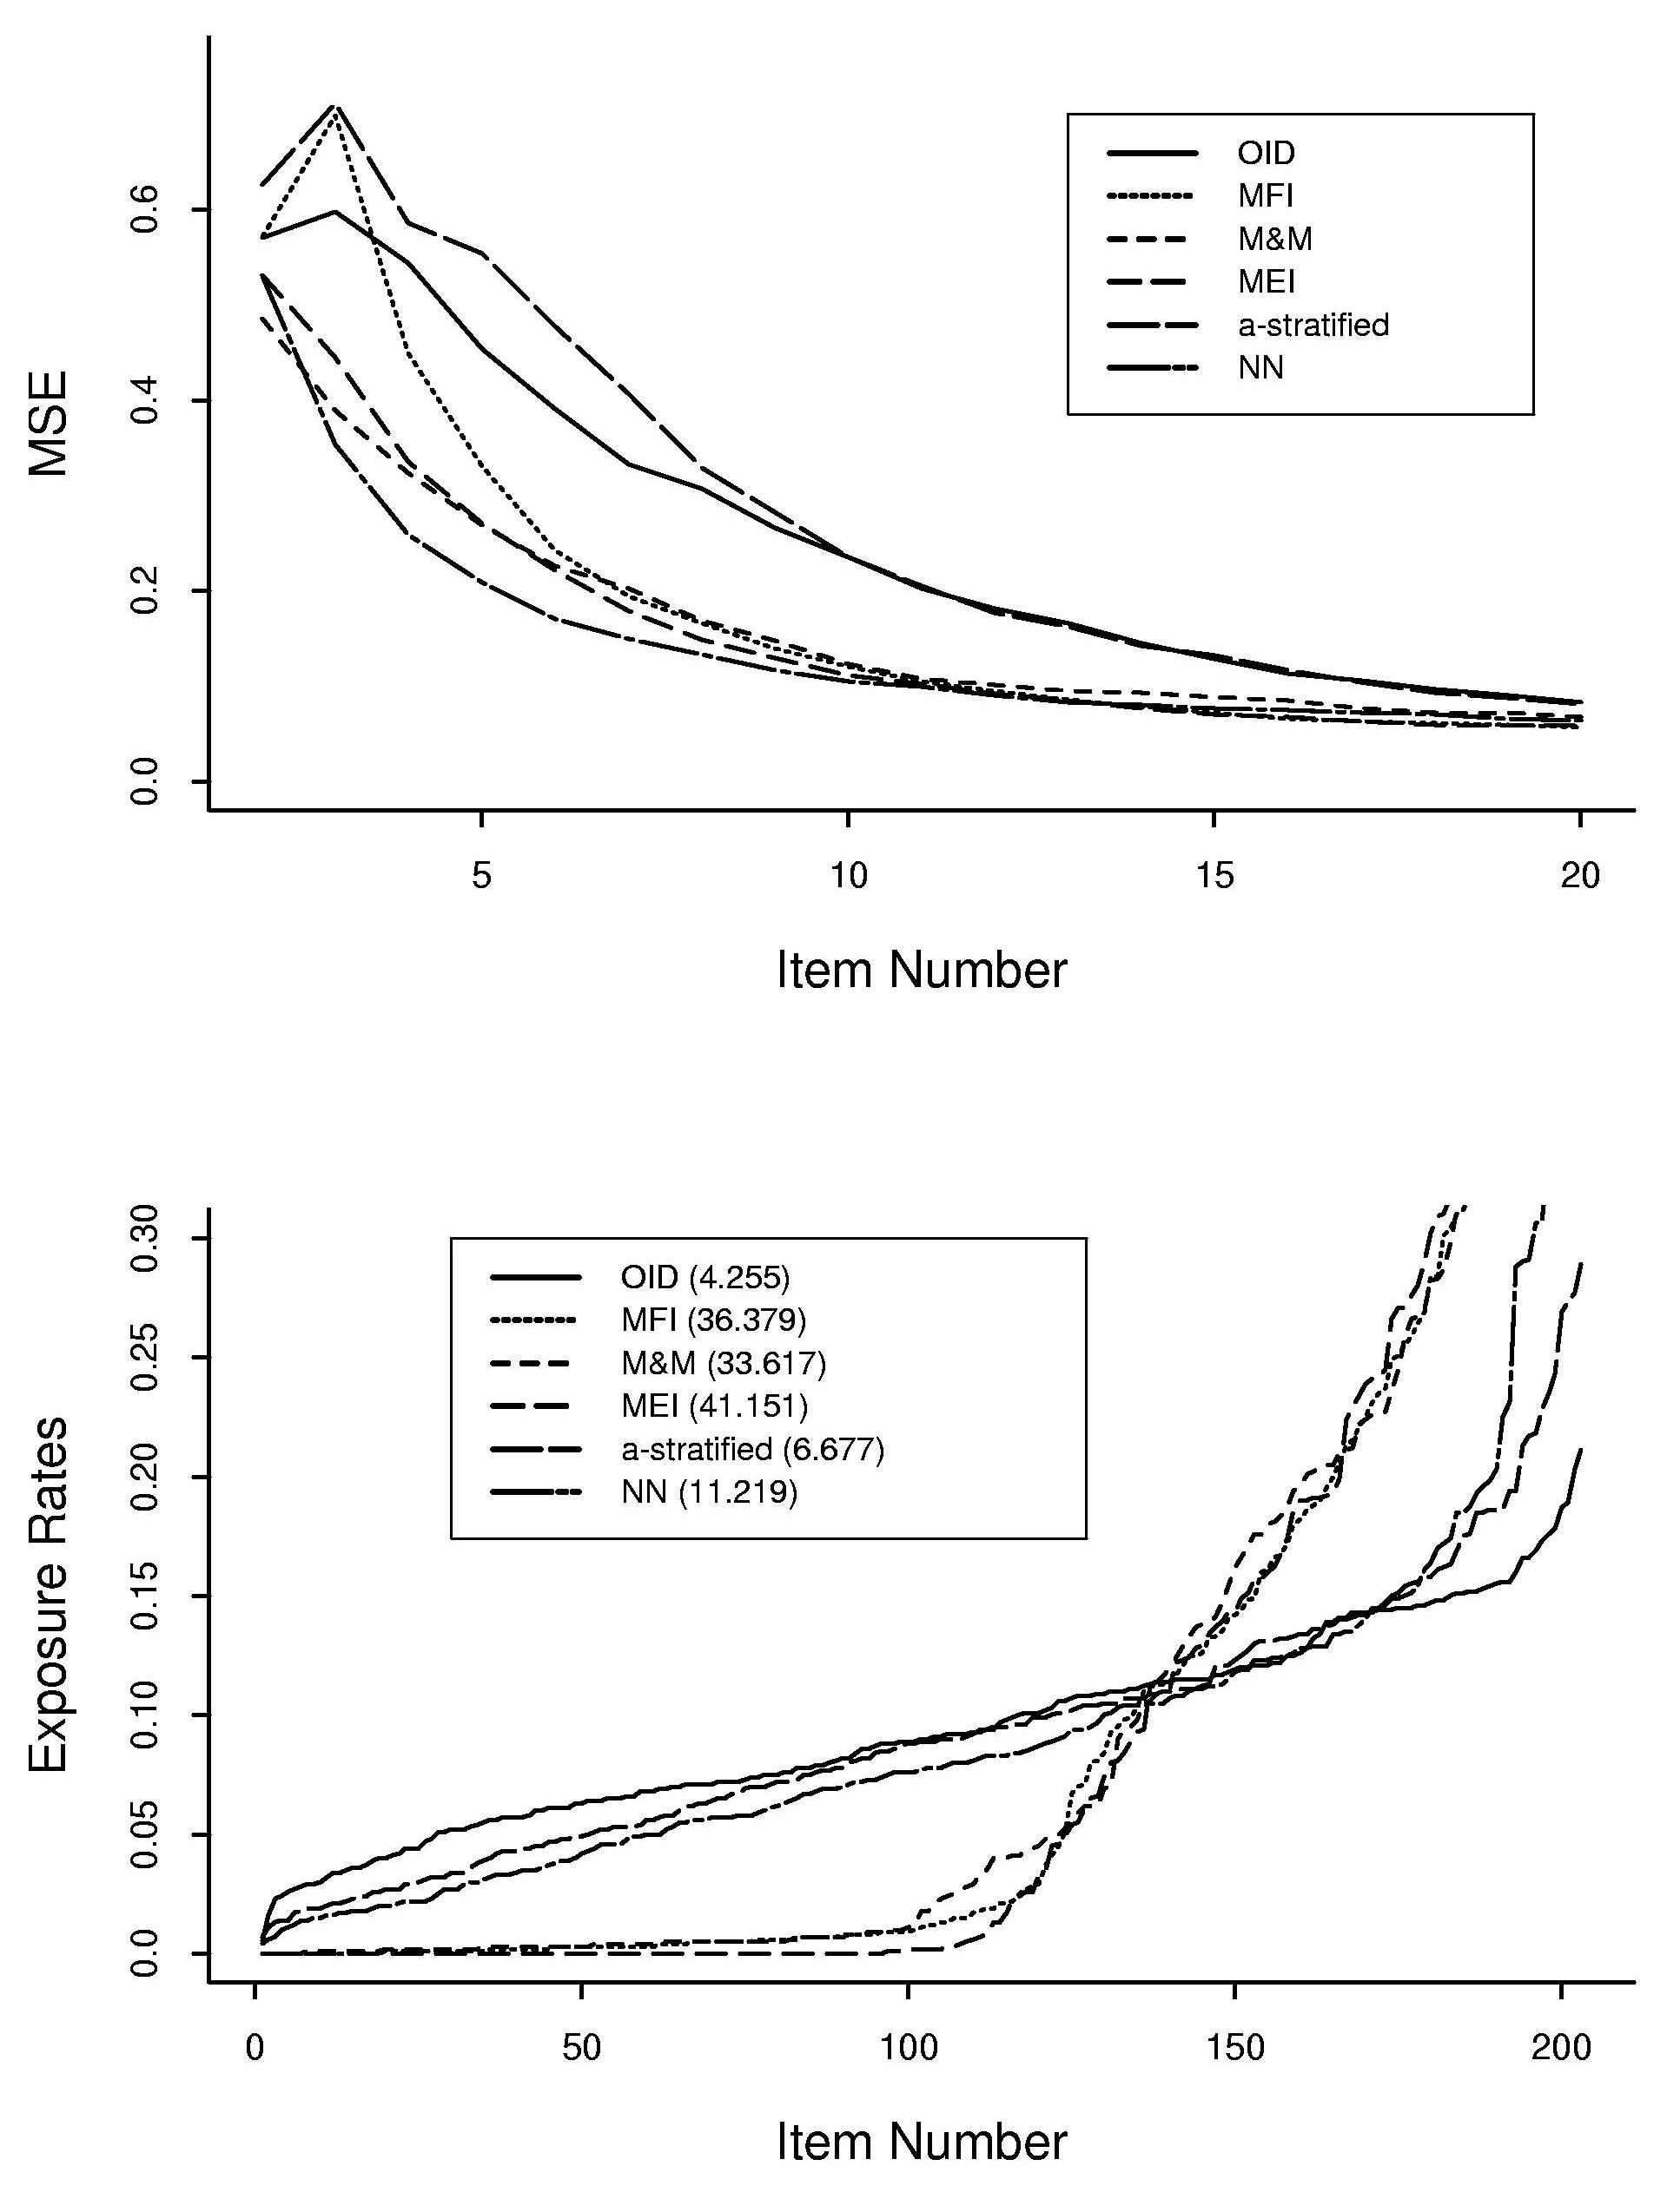
Figure 1: MSEs of estimates and item exposure rates for different item selection criteria (pool = 203 items, mean of theta = -0.024).

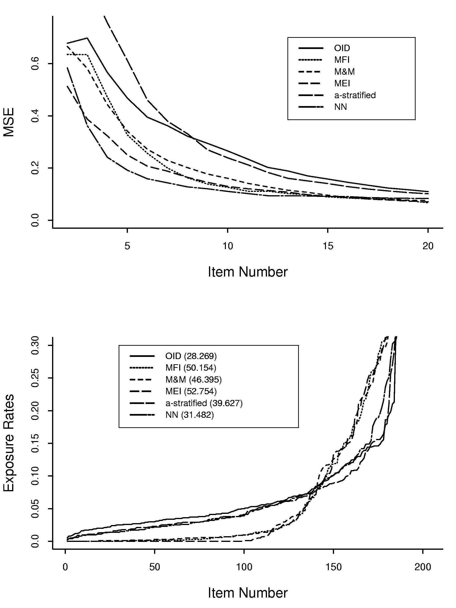
Figure 2: MSEs of estimates and item exposure rates for different item selection criteria (pool = 203 items, mean of theta = 1).

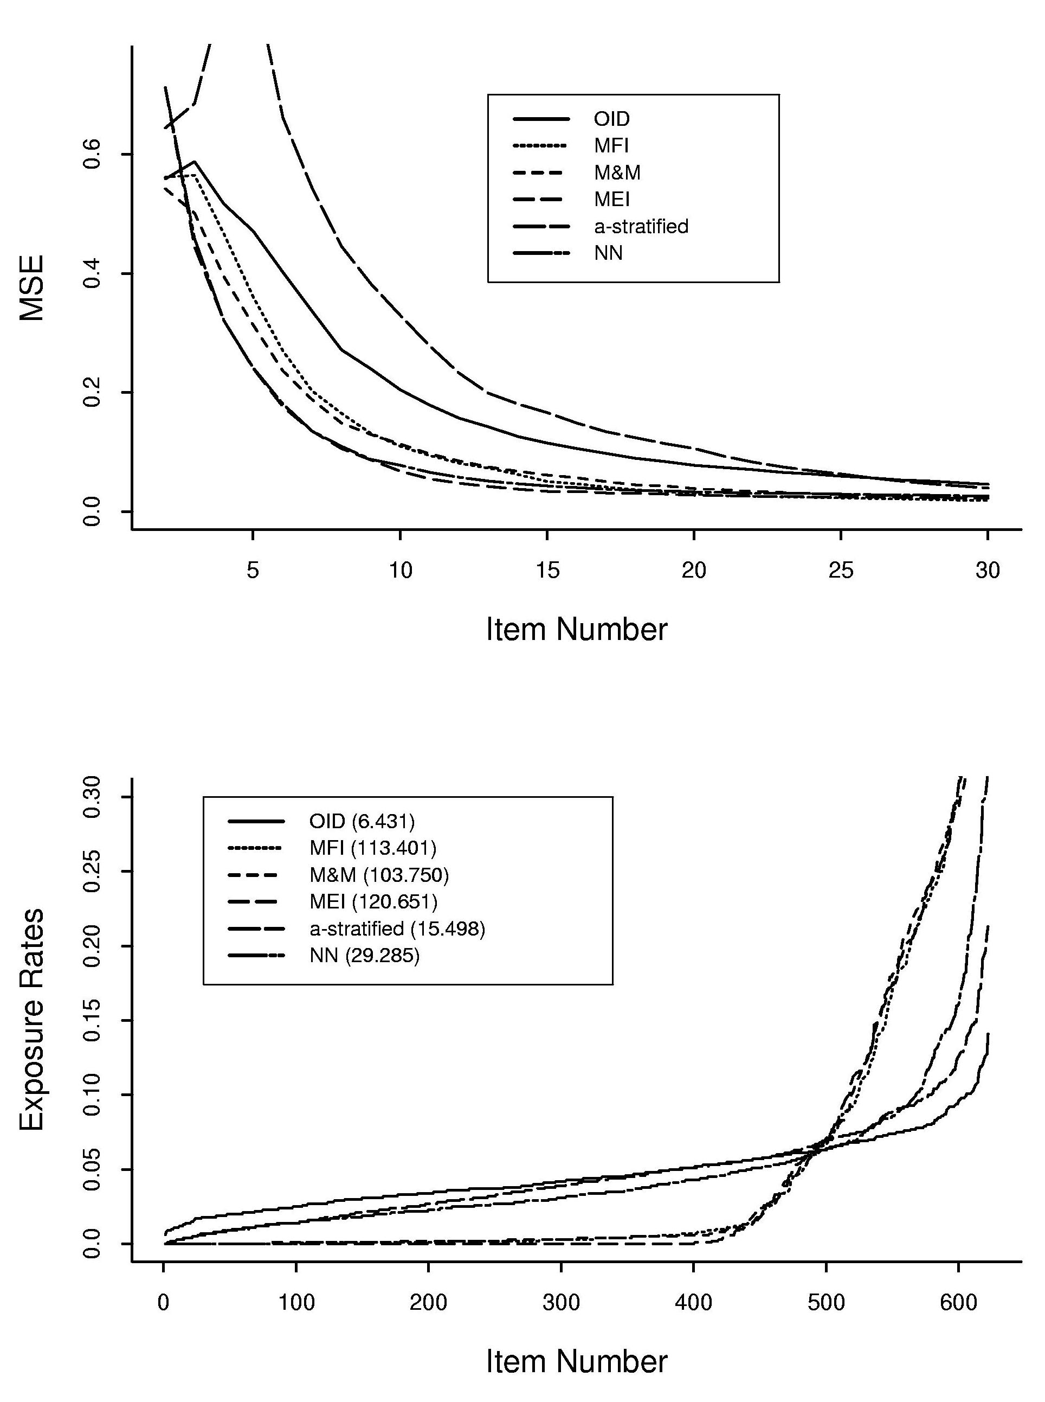
Figure 3: MSEs of estimates (upper) and item exposure rates curves (lower) for different item selection criteria (pool has 622 items, mean of item difficulty = 0.369 = mean of theta); range of item discrimination = (0.321, 4.260) with mean value 1.360, range of item difficulty = (-3.958, 5.275) with mean 0.369, and range of guessing parameter was (0.000, 0.578).
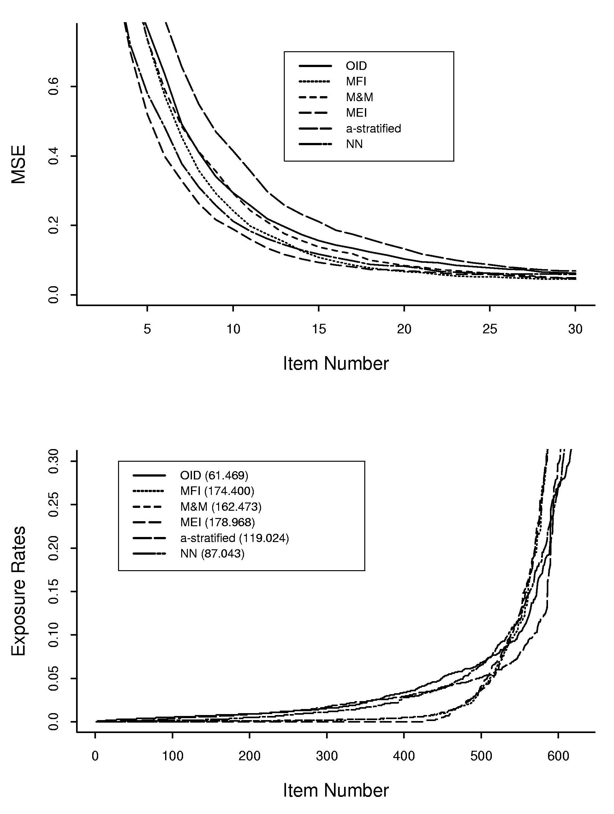
Figure 4: MSEs of estimates (upper) and item exposure rates curves (lower) for different item selection criteria (pool has 622 items, mean of item difficulty = 0.369, mean of theta = -1.0).

References

Anderson, J. A. & Richardson, S. C. (1979). Logistic discrimination and bias correction in maximum likelihood estimation. Technometrics, 21, 71-78.
Birnbaum, A. (1968). Some latent trait models and their use in inferring an examinee’s ability. In F.M. Lord & M.R. Novick, Statistical theories of mental test scores. Reading MA: Addison-Wesley.
Bock, R. D. & Mislevy, R. J. (1982). Adaptive EAP estimation of ability in a microcomputer environment. Applied Psychological Measurement, 6, 431-444.
Chang, H. & Ying, Z. (1996). A global information approach to computerized adaptive testing. Applied Psychological Measurement, 20, 213-229.
Chang, H. & Ying, Z. (1999). -stratified multistage computerized adaptive testing. Applied Psychological Measurement, 23, 211-222.
Chang, S. W. & Twu, B. Y. (1998). A comparative study of item exposure control methods in computerized adaptive testing. Research Report Series 98-3. Iowa: American College Testing.
Cheng, P. E. & Liou, M. (2000). Estimation of trait levels in computerized adaptive testing. Applied Psychological Measurement, 24, 257-265.
Hambleton, R. & Swaminathan, H. (1985). Item response theory: Principles and applications. Boston MA: Kluwer-Nijhoff.
Johnson, E. G. & Allen, N. L. (1992). The NAEP 1990 Technical Report. Washington DC: National Center for Educational Statistics.
Johnson, E. G. & Carlson, J. E. (1994). The NAEP 1992 technical report. Washington DC: National Center for Educational Statistics.
Kolen, M. J. & Brennan, R. L. (1995). Test Equating. New York: Springer-Verlag.
Lord, F. M. and Novick, M. R. (1968). Statistical theories of mental test scores. Reading MA: Addison-Wesley.
Lord, F. M. (1980). Applications of item response theory to practical testing problems. Hillsdale NJ: Erlbaum.
Lord, F. M. (1983). Unbiased estimators of ability parameters, of their variance, and of their parallel-forms reliability. Psychometrika, 48, 233-245.
Luecht, R. M. (1995). Some alternative CAT item selection heuristics (Internal report). Philadelphia, PA: National Board of Medical Examiners.
Mack, Y. P. and Rosenblatt, M. (1979). Multivariate K-nearest neighbor density estimates. Journal of Multivariate Analyses, 9, 1-15.
McBride, J. R. & Martin, J. T. (1983). Reliability and validity of adaptive ability tests in a military setting. In D. J. Weiss (Ed.), New horizons in testing (pp. 223-236). New York: Academic Press.
Mills, C. N. & Stocking, M. L. (1996). Practical issues in large-scale computerized adaptive testing. Applied Measurement in Education, 9, 287-304.
Owen, R. J. (1975). A Bayesian sequential procedure for quantal response in the context of adaptive mental testing. J. American Statistical Association, 70, 351-356.
Stocking, M. L. & Lewis, C. (1995). A new method of controlling item exposure in computerized adaptive testing (Research Report 95-25). Princeton NJ: Educational Testing Service.
Sympson, J. B. & Hetter, R. D. (1985). Controlling item-exposure rates in computerized adaptive testing. In Proceedings of the 27th annual meeting of the Military Testing Association (pp. 973-977). San Diego CA: Navy Personnel Research and Development Center.
van der Linden, W. J. (1998). Bayesian item selection criteria for adaptive testing. Psychometrika, 63, 201-216.
Veerkamp, W. J. J. & Berger, M. P. F. (1997). Some new item selection criteria for adaptive testing. J. Educational and Behavioral Statistics, 22, 203-226.
Wainer, H. (1990). Computerized Adaptive Testing: A Primer. Hillsdale, NJ: Lawrence Erlbaum.
Warm, T. A. (1989). Weighted likelihood estimation of ability in item response theory. Psychometrika, 427-450.
Weiss, D. J. (1982). Improving measurement quality and efficiency with adaptive testing. Applied Psychological Measurement, 6, 473-492.
Weiss, D. J. & McBride, J. R. (1984). Bias and information of Bayesian adaptive testing. Applied Psychological Measurement, 8, 273-285.

